
Better Emotions CIC
EQUAL OPPORTUNITIES POLICY

A) STATEMENT OF POLICY
1. Better Emotions CIC recognises that we live in a society where discrimination still operates to the disadvantage of many groups in society.
2. Better Emotions CIC believes that all persons should have equal rights to recognition of their human dignity, and to have equal opportunities to be educated, to work, receive services and to participate in society.
3. Better Emotions CIC committed to the promotion of equal opportunities within the, Better Emotions CIC and affiliated organisations, through the way we manage the organisation and provide services to the community. In order to express this commitment, we develop, promote and maintain policies that will be conductive to the principles of fairness and equality in the workplace.
4. The objective of this policy is that no person should suffer or experience less favourable treatment, discrimination or lack of opportunities on the grounds of gender, race, colour, nationality, ethnic origin, religious or philosophical beliefs, health status, HIV status, age, marital status, parental status, sexual orientation, political beliefs or trade union membership, class, responsibility for dependents, physical attributes, ex-offender status as defined by the Rehabilitation of OffendersAct 1974, lack of formal qualifications where such qualifications are not formally required, or any other grounds which cannot be shown to be justifiable within the context of this policy.
5. This policy will influence and affect every aspect of activities carried out at xxx CIC i.e. promotional work, educational services, casework and other functions linked to the Better Emotions CIC as determined by the management committee.
6. In the provision of services and the employment of staff, Better Emotions CIC is committed to promoting equal opportunities for everyone. Throughout its activities, Better Emotions CIC will treat all people equally whether they are:
♣Seeking or using our services.
♣Applying for a job or already employed by us.
♣ Trainee workers and students on work experience or placements.
♣Volunteer workers.

B) How the policy will be implemented and who is responsible?
The General Coordinator has specific responsibility for the effective implementation of this policy. Each head of department also has responsibilities and we expect all our employees to abide by the policy and help create the equality environment which is its objective.
In order to implement this policy we shall:
♣ Communicate the policy to employees, job applicants, volunteers and relevant others.
♣Incorporate specific and appropriate duties in respect of implementing the equal opportunities policy into job descriptions and work objectives of all staff.
♣Ensure that those who are involved in assessing candidates for recruitment or promotion will be trained in nondiscriminatory selection techniques.
♣Incorporate equal opportunity notices into general communications practices.
♣Ensure that adequate resources are made available to fulfill the objectives of the policy.

Conduct and general standards of behaviour
All staff and volunteers are expected to conduct themselves in a professional and considerate manner at all times. Better Emotions CIC will not tolerate behaviour such as:

- making threats
- physical violence
- shouting
- swearing at others
- persistent rudeness
- isolating, ignoring or refusing to work with certain people
- telling offensive jokes or name calling
- displaying offensive material such as pornography or sexist / racist cartoons, or the distribution of such material via email / text message or any other format.
- any other forms of harassment or victimisation.

The items on the above list of unacceptable behaviours are considered to be disciplinary offences within Better Emotions CIC and can lead to disciplinary action being taken. Better Emotions CIC does, however, encourage staff to resolve misunderstandings and problems informally wherever possible, depending on the circumstances. However, whether dealt with informally or formally, it is important for staff who may have caused offence to understand that it is no defence to say that they did not intend to do so, or to blame individuals for being over sensitive. It is the impact of the behaviour, rather than the intent, that counts, and that should shape the solution found both to the immediate problem and to preventing further similar problems in the future.

Complaints of discrimination
Better Emotions CIC will treat seriously all complaints of unlawful discrimination on any forbidden grounds made by employees, trustees, clients or other third parties and will take action where appropriate.
All complaints will be investigated in accordance with the organisation’s grievance, complaints or disciplinary procedure, as appropriate and the complainant will be informed of the outcome in line with these procedures.
We will also monitor the number and outcomes of complaints of discrimination made by staff, volunteers, clients and other third parties.

C) Legal Obligations
Equal Opportunities and Discrimination (Equality Act 2010)
The new Equality Act came into force in October 2010 and replaces all previous equality legislation in England, Scotland and Wales – namely the Race Relations Act 1976, the Disability Discrimination Act 1995, the Sex Discrimination Act, the Equal Pay Act, the Employment Equality (Age) Regulations 2006, The Civil Partnership Act 2004, the Employment Equality Regulations 2003 (religions and belief and sexual orientation).
The Equality Act 2010 protected characteristics are:
Age, disability, gender reassignment, marriage and civil partnership, pregnancy and maternity, race, religion or belief sex and sexual orientation.
In valuing diversity Better Emotions CIC is committed to go beyond the legal minimum regarding equality.
The Equality Act 2010 harmonises and strengthens and replaces most previous equality legislation. The following legislation is still relevant:

- The Human Rights Act 1998.
- The Work and Families Act 2006.
- Employment Equal Treatment Framework Directive 2000 (as amended).

D) RECRUITMENT AND SELECTION
1. The recruitment and selection process is crucially important to any equal opportunities policy. We will endeavour through appropriate training to ensure that employees, making selection and recruitment decisions will not discriminate, whether consciously or unconsciously, in making these decisions.
2. Promotion and advancement will be made on merit and all decisions relating to this will be made within the overall framework and principles of this policy.
3. Job descriptions, where used, will be revised to ensure that they are in line with our equal opportunities policy. Job requirements will be reflected accurately in any personnel specifications.
4. We will adopt a consistent, non-discriminatory approach to the advertising of vacancies.
5. All applicants who apply for jobs with us will receive fair treatment and will be considered solely on their ability to do their job.
6. Short-listing and interviewing will be carried out by more than one person where possible.
7. Interview questions will be related to the requirements of the job and will not be of a discriminatory nature.
8. Selection decisions will not be influenced by any perceived prejudices of other staff.

E) MONITORING
1. We will maintain and review the employment records of all employees in order to monitor the progress of this policy.
Monitoring may involve:-
♣The collection and classification of information regarding the race in terms of ethnic/national origin and sex of all applications and current employees;
♣The examination by ethnic/national origin and sex of the distribution of employees and the success rate of the applicants; and
♣Recording recruitment, training and promotional records of all employees, the decisions reached and the reason for those decisions.
2. The results of any monitoring procedure will be reviewed at regular intervals to assess the effectiveness of the implementation of this policy. Consideration will be given, if necessary, to adjusting this policy to afford greater equality of opportunities to all applicants and staff.
Better Emotions CIC will revise and review this policy regularly.
Approved at MC meeting on xxx
Reviewed by the board and signed by Director Eletta Mallisa Palmer-Thompson

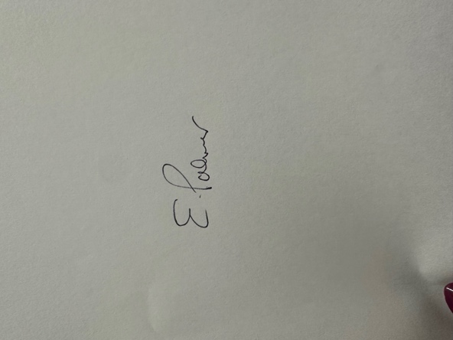

Date: 7th February 2026

